**STELLATE

GAME DESIGN DOCUMENT (GDD)**

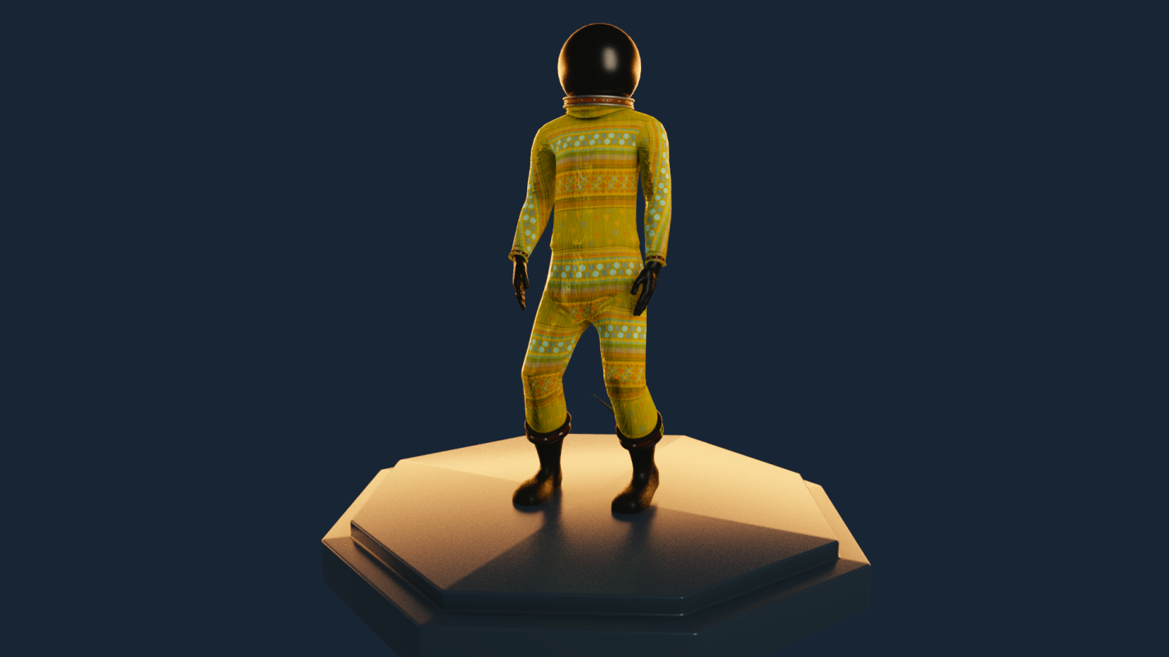

By Orison Softworks
Team/Staff –
**Daniel Tumelo
Yamikani Ntembwa
Muka Konkola
Ganizani Mwale
Daniel Kaluba
Mwauluka Nambula**

Contents
GAME DESIGN FEATURES -......................................................................................... 3
Title – Stellate................................................................................................. 3
Description/feature set – .......................................................................................... 3
Purpose/application –............................................................................................... 3
Premise/high concept –............................................................................................ 3
Genre – .................................................................................................................... 3
Style – ...................................................................................................................... 3
Platform –................................................................................................................. 3
Audience/market – ................................................................................................... 3
Rating –.................................................................................................................... 4
Player mode –.......................................................................................................... 4
Time interval –.......................................................................................................... 4
Backstory – .............................................................................................................. 4
Character descriptions – .......................................................................................... 4
Competitive analysis – ............................................................................................. 5
Rules –..................................................................................................................... 6
Challenges – ............................................................................................................ 7
User Manual –...................................................................................................... ….8
Audio –................................................................................................................... ...9

3. GAME DESIGN FEATURES –

Title – Stellate

Description/feature set –

Stellate is a single-player Sci-Fi Puzzle Platformer, set in the Sixties in Northern Rhodesia at the height of The Cold War, and invites you to take part in one of the most storied years in the history of the visionaries in Zambia.. The player is to identify with the main character Edward Mukuka Nkoloso or "The Afronaut" as they are forced to learn much faster than they ever thought they had to. Stellate promises to be a journey the player won’t soon forget.
Stellate’s features include the following:

- A completely immersive Linear-threaded storyline.
- Quirky and edgy graphics and landscapes portraying unique new worlds.
- An intricate puzzle system that ranges from the properties of time to Quantum Mechanics in the Quantum Realm.
- Soundtrack featuring original soundscapes written and composed specially for this game.
- English localization of all written and spoken dialog.

Purpose/application –

To engage players in a puzzle solving adventure that is sci-fi story oriented. We want players to remember the adventure as “space-time simulation and molecular visual mindtrip .

Premise/high concept –

Immediately following the construction of your Rocket, you launch into space. Breaking the space-time barrier through a blackhole, you find yourself in the quantum realm where you quickly determine that you are separated from the physical earth bound realm and that you must escape the alien environment. During this quantum-realm journey, you will be bound to the laws and properties of time-space in the quantum realm and quantum mechanics.

Genre –

Stellate is a Sci-Fi/Puzzle-Adventure 2.5D game. The game will take place in the Quantum realm, each level with its unique properties, aesthetics and architectures.

Style –

The colors and appearances of the game will be semi-life-like, with artistic ambient color.
Look to the environment similar to Inside(The Game), but more quirky. Models will be lifelike and to scale…Edward M. Nkoloso/The Afronaut, yet proportionate to a human with a physique befitting a martial artist/arena fighter in good physical condition. Alien species/Intelligent elements will vary based on the environments of their home worlds. A low gravity world may produce portals, puzzles and creatures with
a cell/bacteria like appearance and be generally weak on typical worlds, while worlds with higher gravity may produce Intelligent Elements with more appendages and significantly Harder puzzles[portals included] in a 2.5D camera view/perspective and a 5 second 3D view/perspective.

Platform –

Stellate is intended as a platform release for the PC.

Audience/market –

The target audience for Stellate will be fans of Puzzle, adventure and sci-fi games. Gamers
experienced in Adventure Puzzle Platformers (players of Braid, Inside, Limbo, Fez and other similar titles) will find familiarity in the game, and will find the game
piquing their curiosity and interest.

4. Rating –

The expected target Age Rating for Stellate is “E” for Everyone. But recommended for Teen to Mature player audiences. This game will contain introspective, involving and "use of brain-power" situations. The content is determined to be for players interested in sci-fi research concepts, and is not primarily intended for a conventional juvenile experience.

Player mode –
Stellate will be a single-player adventure.

Time interval –

Stellate will be played in a checkpoint time interval. As with most games in the Puzzle genre, there
will be no time limit to progression, and players are expected and encouraged to think as they explore the game-world puzzles.

Backstory –

From 1960 until sometime after 1969, Edward.M.Nkoloso spear-headed a space program sought to accomplish the launching of a rocket that would send one girl, 17-year-old Matha Mwambwa, and two cats to the moon. There were also plans for a trip to Mars. Nkoloso hoped to beat the United States and Soviet Union's respective space programs at the height of the Space Race.
To train the astronauts, Nkoloso set up a makeshift facility on an abandoned farm 11 kilometres (7 mi) from Lusaka where the trainees would be rolled down a rough hill in a 200-litre (44 imp gal) oil drum. This, according to Nkoloso, would train the men in the feeling of weightlessness in both space travel and re-entry. In addition, they used a tire-swing to simulate weightlessness. Nkoloso stated goals of the program were to establish a Christian ministry to "primitive" Martians, and the hope of Zambia becoming the "controllers of the Seventh Heaven of Interstellar space". However, he reportedly instructed the missionary in the space program not to force Christianity onto the native Martian inhabitants. The rocket, named D-Kalu 1, was a 3-metre by 2-metre (10x6 ft) drum-shaped vessel. Named after the first president, Kenneth David Kaunda, he claimed it was made of aluminium and copper, and space worthy. It is said that he then asked UNESCO for a grant of £7,000,000 in Zambian pounds to support his space program. It is also said he requested $1.9 billion from "private foreign sources". However, the Ministry of Power, Transport and Communication is reported as stating those requests had not been made on the behalf of Zambia.
The term "Afronauts", coined by Nkoloso, refers to the participants of this program.
Interviewed in 2016, former Zambian president Kenneth Kaunda said of the space program that "It wasn’t a real thing ... It was more for fun than anything else. The planned launch date was on 24 October 1964, Independence Day, and would take place from the Independence Stadium, but was purportedly denied permission due to being inappropriate.... or was it?..
Character descriptions –

The following is a list of characters for Stellate. The first and only character is the main character which is playable.

i) Edward.M.Nkoloso/The Afronaut (Main Character) –
Play as Edward The Afronaut.

5. Competitive analysis –

Stellate will aspire to be compared to FEZ(Polytron), Braid(Number none), and Inside
(PlayDead Studios). The following competitive analysis is provided for each of
these titles:
i) FEZ –
Fez is a two-dimensional (2D) puzzle platform game set in a three-dimensional (3D) world. The player-character Gomez lives peacefully on a 2D plane until he receives a red fez and witnesses the breakup of a giant, golden hexahedron that tears the fabric of spacetime and reveals a third dimension. After the game appears to glitch, reset, and reboot, the player can rotate between four 2D views of the 3D world, as four sides around a cube-like space. This rotation mechanic reveals new paths through the levels by connecting otherwise inaccessible platforms, and is the basis of Fez's puzzles. For example, floating platforms become a solid road, discontinuous ladders become whole, and platforms that move along a track stay on course. The object of the game is to collect cubes and cube fragments, which accrete to restore order to the universe. In search of these cubes, Gomez traverses the game environment by jumping between ledges. Other platforming elements change with the level themes, including crates that activate switches, bombs that reveal passages, and pistons that launch Gomez airborne.

ii) Braid -
Braid is played by solving physical puzzles in a standard platform game environment. The player controls the protagonist Tim as he runs, jumps, and climbs across the game's levels. Tim jumps and stomps on enemies to defeat them, and can collect keys to unlock doors or operate levers to trigger platforms. A defining game element is the player's unlimited ability to reverse time and "rewind" actions, even after dying. The game is divided into six worlds, which are experienced sequentially and can be entered from different rooms of Tim's house; the player can return to any world previously visited to attempt to solve puzzles they missed.

iii) Inside –
Inside is a puzzle platformer. The player character is an unnamed boy who explores a surreal environment presented as a monochromatic 2.5D platform game. The game is dark, with color used sparingly to highlight parts of the environment, and mostly silent, with occasional musical cues. The player controls the boy who walks, runs, swims, climbs, and uses objects to overcome obstacles and progress in the game. The boy gains the ability to control bodies to complete certain puzzles, a mechanic that IGN's Marty Sliva compared to a similar mechanic in The Swapper. At various points in the game, the player may discover hidden rooms containing glowing orbs. If all the orbs are deactivated during a playthrough, the player unlocks the game's alternate ending.

6. Rules –

Stellate is a single player Sci-fi Puzzle Platformer. This game could take as little as a week to complete if the
player chooses to play it casually. The introspective and intricate nature of this game allows the player to
play the game at their own pace. The game’s length is set to be at least 3 to 4 hours long.

7. Challenges –

Below are 5 representative world challenges that players will need to overcome in order to progress in Stellate. Many other challenges will be in the final product.

i) Arrow of Time: plays as an introduction to the platform gameplay through warp-portholes, except that the player's ability to turn back at free will will result in an instance of superposition spawning the player back to a certain starting point. This mechanic would be unplayable or unfair in an ordinary platform game, but becomes feasible when the 5 second perspective camera view mechanic is available.

ii) Cartesian-Twist: switches the axis points of the player, such that the x-axis converts to the y-axis and vice versa.

iii) Quantum Entanglement: involves duplicates of the player character appearing in and at random points ; Puzzles in this section revolve around completing the puzzles with each duplicate. This mechanic is to carry out multiple actions at once.

iv) Zero-gravity: introduces the concept of anti-gravity for a limited time, after which, the wave of string theory manipulates the position of the portals ergo the puzzle. The completion of this puzzle will take the player out of the Quantum realm to a Simulated Maze.

v) The Labyrinth: In this world, the 3D perspective is the primordial camera view and the objective is to find the exit through a complex Labyrinth.. Once this is complete. The player is restored to what appears to be a normal space-time zone with regards to everything being "normal" again... only to discover that the journey he went through was a simulation.

8. User Manual –

The User Manual will cover the following elements:
i) System requirements – System Requirements for PC, network connection requirements
The space required for installation of the game for the given platform will be given, and
health warnings for taking frequent breaks from the game, photo-sensitivity/epilepsy, and
need for healthy eating when playing video games.

ii) Backstory - Players will be given the backstory of the game.

iii) Controls - Use of the primary controller, its default settings, and how to customize the
key/button map will be diagrammed.

iv) Credits – Credits for the game will be included in the manual. All acknowledgement,
remarks, and dedications will be placed within the in-game credits.

9. Audio –
Stellate will incorporate a full range of audio elements commonly used in sci-fi titles. Background
music and sounds will be unique and adaptive/reactive according to location and player interaction.
Sound effects for everything from footsteps to world soundscapes envelop the player in a realistic and maybe uncomfortable but engaging auditory range suspending reality, and drawing them further into the game.

----END-------

